InBred, Linebred, and Outcrossed by William Given

Excerpted from the September 2014 article in the Canine Chronicle

Ed Note: As you start to read this article you may quickly lose interest if you are not a breeder and never plan to be. Be advised to stick with it. Anyone who loves the GSP they share their life with, not just those who breed, should have a basic understanding of how the wondrous creatures get to be what they are. When it comes time to search for another one, passing knowledge of how pedigrees are crafted and what the heck the breeder is trying to explain about a particular family of dogs will serve you well. Learning about what Mr. Given is sharing here will give you some new ideas on where to find another dog with as good a nose, as much prey drive, as fine a headpiece, or strong a topline as your current prized companion.

Inbreeding, line-breeding and outcrossing are terms describing the three methods for blending canine bloodlines to achieve a desired consistency of genotype and phenotype. Used wisely, they provide enlightened breeders with an array of valuable systems to aid in determining the direction and control of a well-planned breeding program. Each plays a vital role in the preservation and maintenance of the breed and its most desired characteristics. Defined briefly:

Inbreeding is the breeding of two dogs that are very closely related to one another, a sister to a brother, sire to daughter, dam to a son, and in some cases the mating of half-siblings or aunts and uncles with nephews and nieces. Because inbreeding amplifies the genes for weaknesses as well as for strengths, inbreeding can be either highly successful or a dismal failure. Use of this method requires one to accept the disappointments that are mathematically certain to occur.

Line-breeding is a much more conservative form of inbreeding. It usually involves the breeding of more distant relatives in the interest of concentrating the gene code of a specific stud dog and brood bitch, thereby intensifying the probability of developing prepotency for superior traits of the two dogs. The more often a particular dog appears in the pedigree, and the closer to the front, the more tight the line-breeding has become.

Outcrossing as you might expect is the mating of two dogs not related to each other. It is also a term used for breeding away from certain families and bloodlines that have become too tightly bred and need an infusion of “outside blood”. Outcrossing is generally used to reestablish overall health and fertility that may have been lost through inbreeding or extended line-breeding.

Basic Genetics

Genes are bits of DNA molecules that dictate every heritable trait that makes a dog all that he is. Genes carry pairs of alleles that modify given traits to a greater or lesser extent. When paired, these alleles are said to be dominant if the traits they express override other traits found on the corresponding allele. They are said to be recessive if these traits are unexpressed due to the presence of other overriding dominant alleles. A gene is said to be homozygous if the paired alleles are both dominant, in which case the dog will always pass on a dominant allele to its offspring. It is said to be heterozygous if the paired alleles contain one dominant and one recessive component. The dominant allele will be the one expressed, but the recessive allele is still present, and could be passed on to offspring.

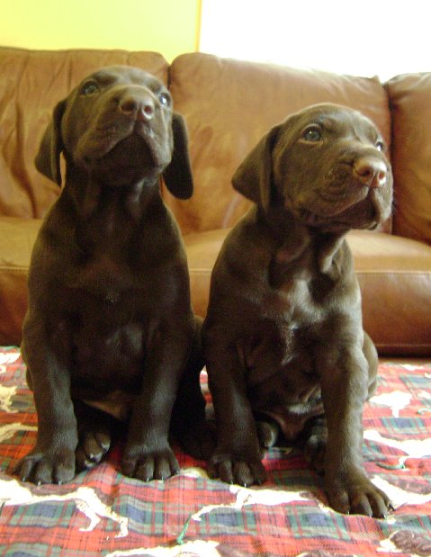
Shorthairs have a very graphic expression of gene dominance
in the inheritance of the solid liver color. CH Claddagh’s
Legendary Knight RN and CH Claddagh’s Knight Train each received the
dominant allele for liver from their solid liver sire.

Each parent of a dog contributes 50 percent of its genetic material to each one of its offspring. 25 percent of this material was received from each of its parents in turn. If for example you are breeding two dogs that have nothing in common, depending on which 50 percent of genetic code was contributed by sire and dam, all of the offspring could look quite different. If this is the case, the good news is that no major weaknesses are turning up. Weak breed characteristics are very frequently recessive traits, and are thus unexpressed unless concentrated in a manner that makes them homozygous. Therefore your puppies should be relatively free of congenital health concerns, should achieve at a minimum, average conformation, overall health and well-being, and fertility for the breed. The bad news is the lack of dominance for certain traits you desire may be keeping you from getting the consistently good quality you really want. This is a classic outcrossing dilemma. The results are safe, but not necessarily spectacular

.

Selecting For A Desired Trait

To illustrate the practice, say your bitch has a grandsire much admired for a certain set of traits that he passed on to his get with great regularity. His granddaughter, if you have been lucky in your choice of bitches, inherited some of these qualities from him, but she would not have gotten more than 25 percent of his genetic material altered by the presence of the other 75 percent of genes she inherited from other ancestors. If you breed her to an unrelated dog, the contributions of her superlative grandsire will become even further diluted.

To ensure that the inheritance of that lovely bitch will be passed on with increased probability, you may choose to breed to another son or grandson that expresses the same strengths. You might even go so far as to flirt with inbreeding, and breed your bitch back to her grandsire or an equally handsome full brother of his. The goal of the mating would be that resulting offspring will have a greater concentration of the desired genetic material. This concentration of genetic material also results in a higher incidence of homozygosity, i.e. dominance, for certain desirable traits. If this occurs, the puppies resulting from such a breeding could have a prepotency for some of those desirable traits; passing them on to offspring with consistency due to the dominance of the alleles concerned. If you have been in sport long enough, you surely have heard breeders talk about a dog that “stamps his get/her produce”. This is what they mean.

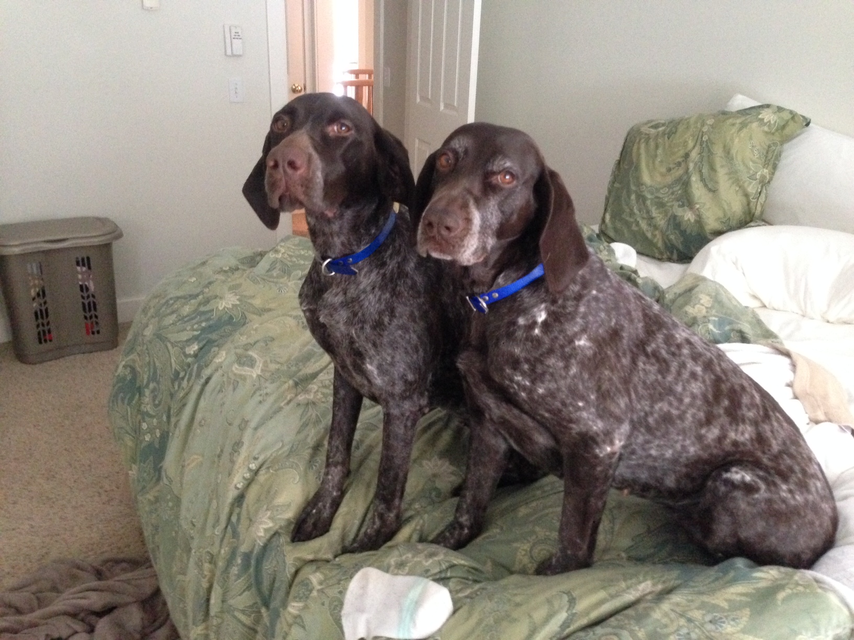
GCH Kan-Point Ehrenvogel Luv Comes 1st CD RFC “Dani” pictured right has a pedigree as described
above; linebred to concentrate her genetic material. Though her litter’s pedigree is an outcross,
she clearly stamped her daughter Callie with a good measure of her physical attributes. Both dogs
owned by Shane and Christine Baxter.

By now you may be wondering, if inbreeding and line-breeding result in creating superior dogs by intensifying all that great genetic code, why are we not doing it all the time? Well, there are, of course, several reasons. The single greatest reason is that when certain genetic material is being combined in a highly concentrated manner, it also magnifies whatever weaknesses have been masked by the dominant genes. In our example, although the grandsire possessed many absolutely outstanding qualities, he also had very bad feet. Perhaps bad feet are almost unknown in the breed, so this aberration went all but unnoticed as long as the grandsire was bred to bitches whose feet were at least as good as average for the breed. The bad feet in this example remain recessive, masked by the breed’s dominant genetic inclination toward good feet.

When you start experimenting with inbreeding and line-breeding, whatever genetic combination occurred to give the grandsire bad feet will be made stronger by the concentration of that trait. It is thus possible that when you breed your bitch to a related stud dog, and both have decent feet, you may be shocked when you are presented with a litter that typifies everything you wished for, except for having terrible feet. A large breeder with time and money to spare may look at this situation as a learning experience, cull this litter from the breeding program, and breed the bitch back in hopes of getting better feet. If the second attempt succeeds, and it certainly could, the pick puppy can be kept for the future and the others placed in good homes. The unexpressed tendency to bad feet will remain recessive unless a future breeding with another dog with the same genetic concentration brings it out again.

However a small breeder will not have the luxury of trying that breeding a second time and may feel forced to keep one or two of the puppies as breeding prospects despite their feet. In this case the genetic code for bad feet will be passed on yet again, perhaps now as a dominant trait. And so the unwary breeder has unintentionally loosed a heritable defect into the gene pool.

The Shrinking Gene Pool

The other drawback of consistent inbreeding or line-breeding is that, over time, if you continue to breed close relatives through a number of generations, it decreases the gene pool to the extent that many good qualities will be lost in the shuffle. By definition, inbreeding reduces the numbers of gene pairs that can be inherited by any offspring, which is why inbred dogs have such a high prepotency for certain traits. The process of inbreeding eliminates a wide variety of alleles from the genetic code of those dogs. Inbred systems, over time, will suffer from a general loss of size, fertility and vigor. The more inbred a dog is, the more homozygous its genotype, and the less access is available to traits that are dependent on a variety of alleles for their expression.

The loss of vigor, and resulting genetic weaknesses that occur with it, are not solely created by inbreeding. These can be traits that may have existed in a recessive state and have been expressed due to the consistency of their concentration by breeding back into the line of dogs that carry them. Or it may be just as easily that traits including vigor, fertility, and freedom from genetic weakness rely on herterosity to be expressed and maintained in a healthy state.

The Right Balance

Inbreeding and line-breeding should always go hand in hand with judicious outcrossing to ensure the continued overall health, fertility, intelligence and temperament of your dogs. Inbreeding and line-breeding can certainly produce the spectacular individuals you have dreamed of, but Mother Nature has proven over and over again that the greatest “meshes” are often those that occur between two unrelated (though possibly line-bred within themselves) individuals whose genes combined to produce what is commonly referred to hybrid vigor.

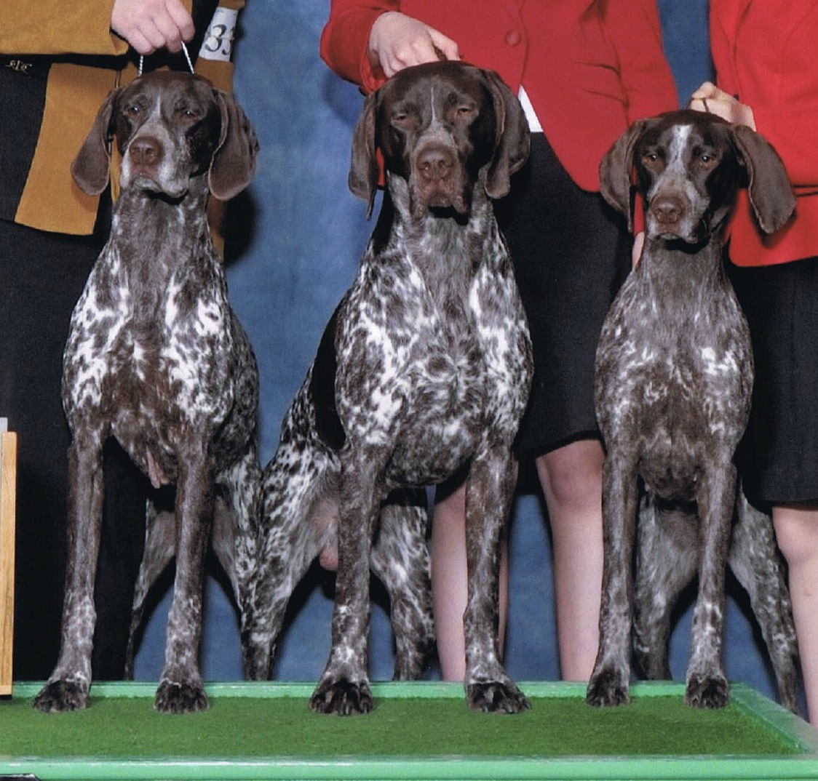
This Tothepoint family group has what breeder Karen Combs
hopes is a pedigree brimming with hybrid vigor. The
dam, Paige, is gently outcrossed to a sire whose pedigree contains
two significant common sires with her dam’s bloodline 3-4
generations back. Karen bred her to a sire line bred
on one of these common ancestors.

Geneticists readily admit they are not quite sure why it is that hybrid vigor works, but there is no arguing with the fact that in certain circumstances the breeding of two unrelated lines will result in the genesis of a litter far superior to their parents. This is especially true in the context of traits controlled by a number of different genes, rather than expressed very specifically. Two examples of the latter would include working ability and intelligence. The former consists of a variety of alleles controlling traits in the realm of conformation and movement. Size, which tends to be genetically programmed, can be affected strongly by environmental factors such as nutrition. Bone is generally considered to be moderately heritable, relying in part on its genetic dominance in certain bloodlines. Thus it is that increased heterosity, or the exposure to a broader array of genetic material, increases the chances of a given pup inheriting the combination of genetic code that will result in superior dogs.

The Magic Mesh

If the genetic code passed on by your dog has an affinity for that of its mate (more correctly put, if the alleles concerned combine in a way that produces dominance in certain important respects while masking any recessive traits that would be undesirable) then you have the puppy of your dreams – not just once, but repeatedly. The discovery of these nicks is 75 percent pedigree research and hard work, 20 percent intuition and five percent dumb luck. Even geneticists freely admit that luck, chance and happenstance play a major role in the final genetic inheritance of full brothers and sisters. For this reason, you are likely to get one superstar, a couple of above average performers, one or two strictly average, and a sire and dam both worth their weight in pure gold.

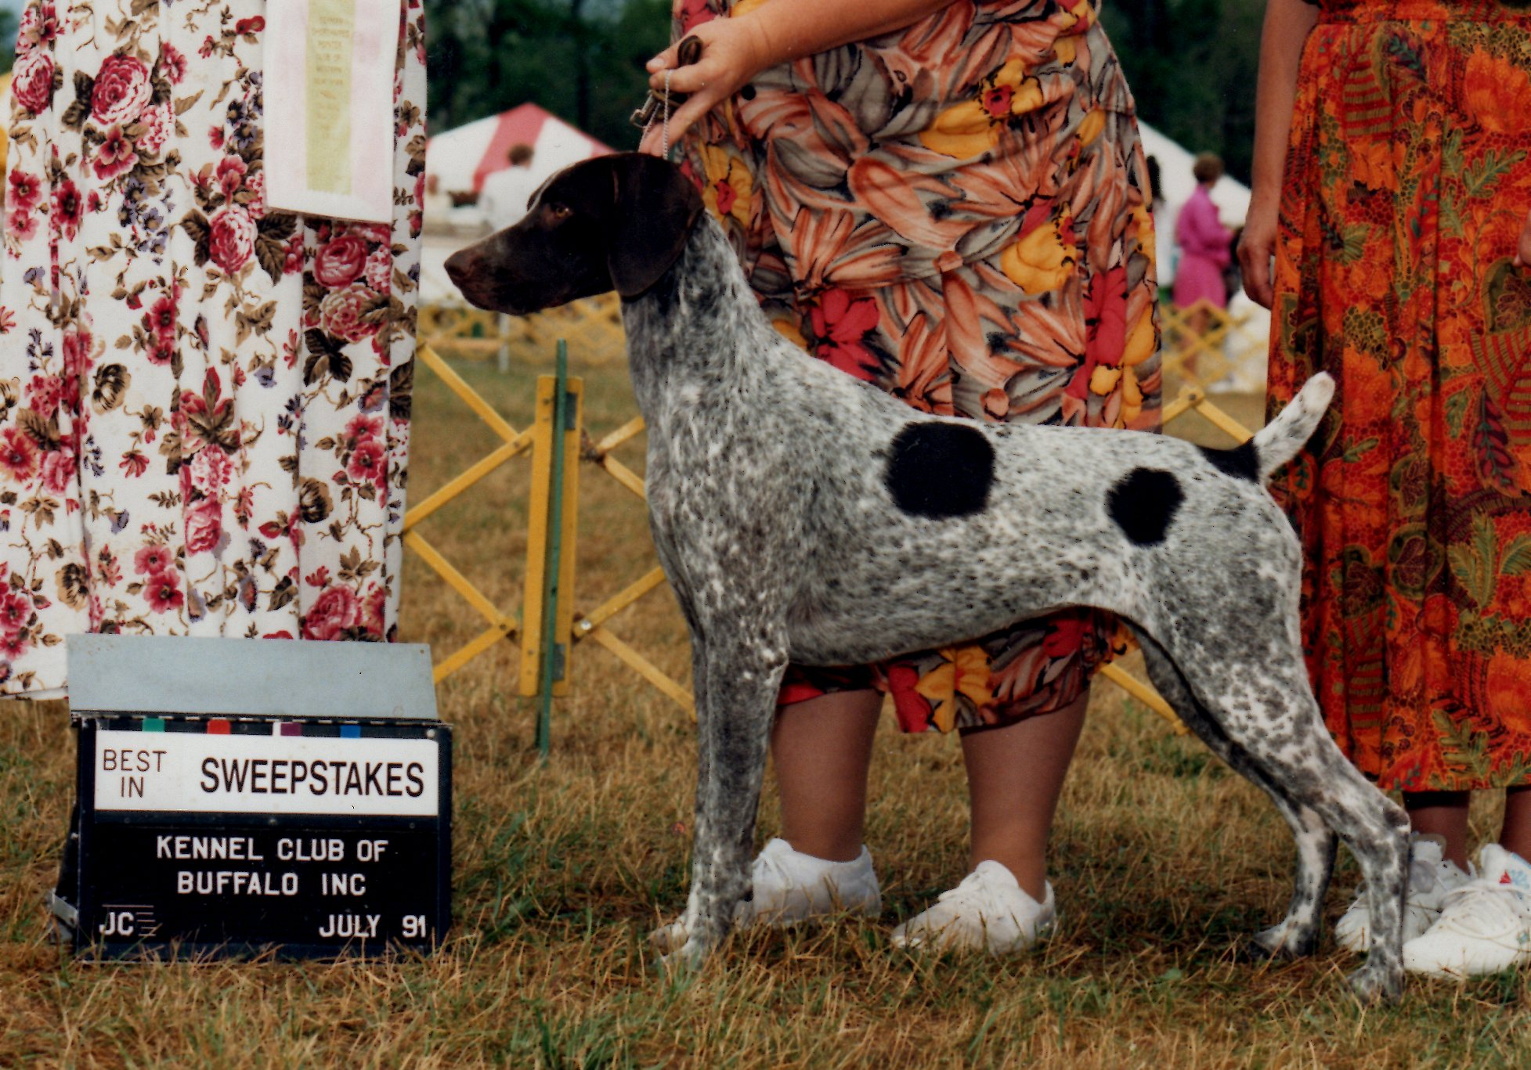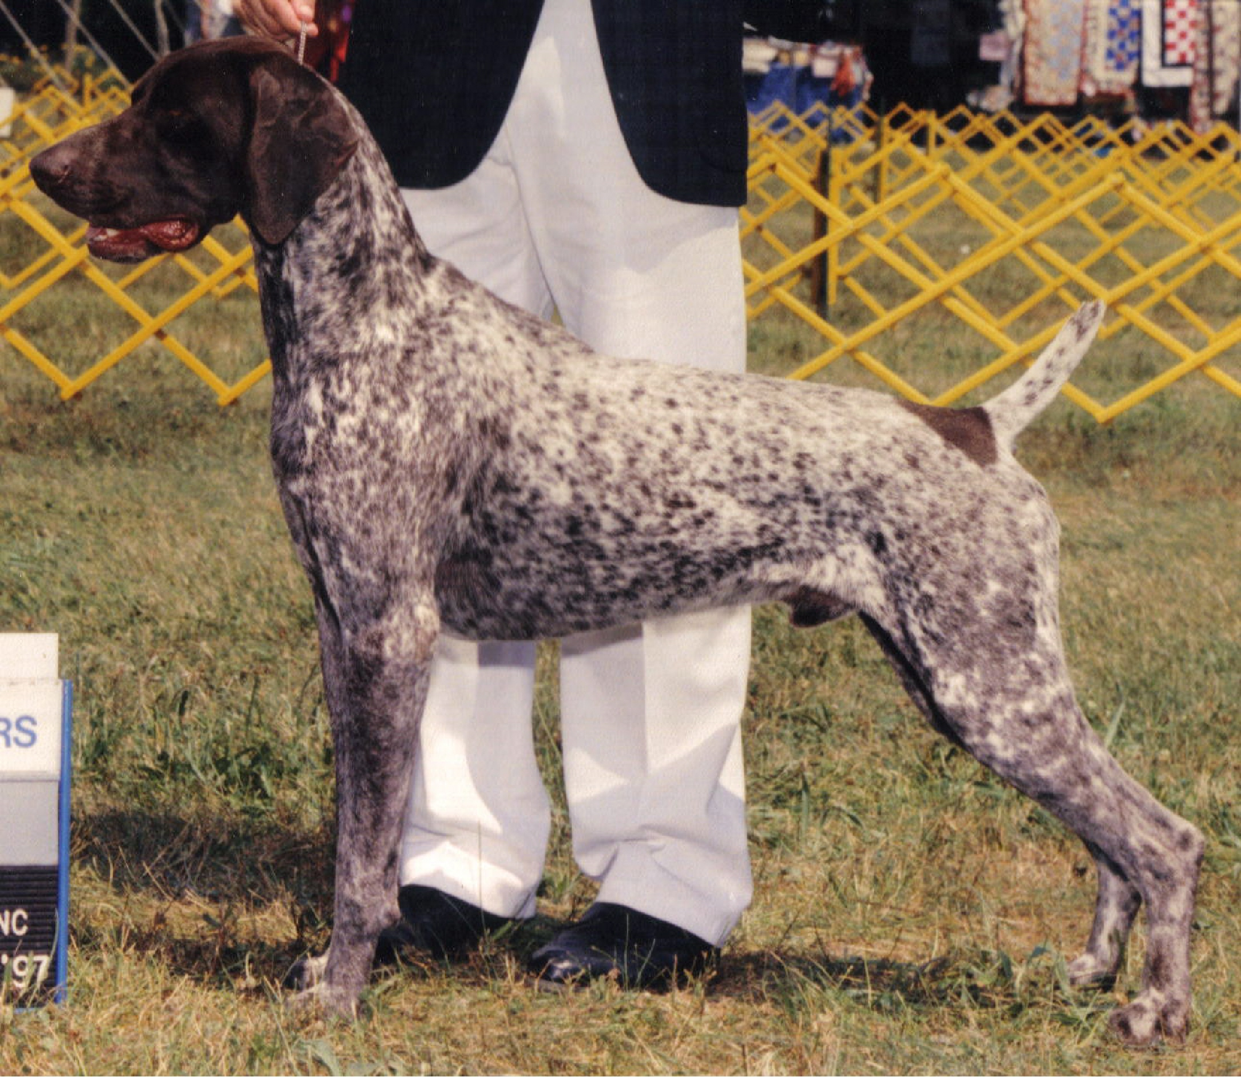
Tightly line-bred CH Sonnenschein’s Paisley Print(left) bred to CH Leiblinghaus Chief Executive
with a pedigree going back to the origins of her own. Son CH Sonnenschein’s Chief Justice (right)
clearly inherited most of his dam’s physical attributes.

Unfortunately, the top ranked dogs of today may not even pass their outstanding qualities on to the next generation with anywhere near the consistency of their parents. The variety of attributes that has made them great can combine with the next generation’s breeding in ways that are varied and erratic. It depends greatly on the genetic code added by the breeding partner. And so, the cycle begins again. The question of whether to line-breed and how much, or whether to inbreed and to whom, when to outcross and which lines will provide the needed “punch” to create the next generation of superstars. It is your knowledge and intuition that will increase your chances of succeeding.

